**Name \** Mohamed Ahmed Abd Elnafea Mohamed Kassem

محمد أحمد عبد النافع محمد قاسم

**B.N \** 649

**Topic \** programming language

**Application Brief:**

Programming is the process whereby a programmer writes code, represented by a set of commands, which are executed on computers in turn.

The human world communicates with each other through different languages, so scientists have invented a new unique way of communicating with computers and other digital devices in the world of information technology, which are orders and instructions for different digital devices so that we can communicate what we want from and to the device, and how to modify it or even deal with it.

The programming languages that programmers need to handle data in digital devices are different and these languages are differentiated in the form of computer writing commands. Every language has a special vocabulary, specific to the rest of the languages, based on the mission and the system in question. The handling of data in the past was very simple, based on the principle of algorithms, as for every entry on which mathematical operations are performed we finally get the required result and on this basis were designed, invented and developed programming languages ​​in dealing with data and methods for dealing with problems, and programming languages ​​graduated between languages Low level and high level which are: (C, Java, Delphi, non-serial object languages) and procedural (Basic, Fortron)

**Screen shots:**

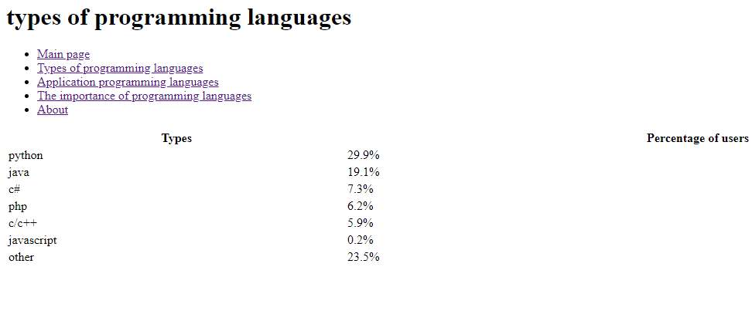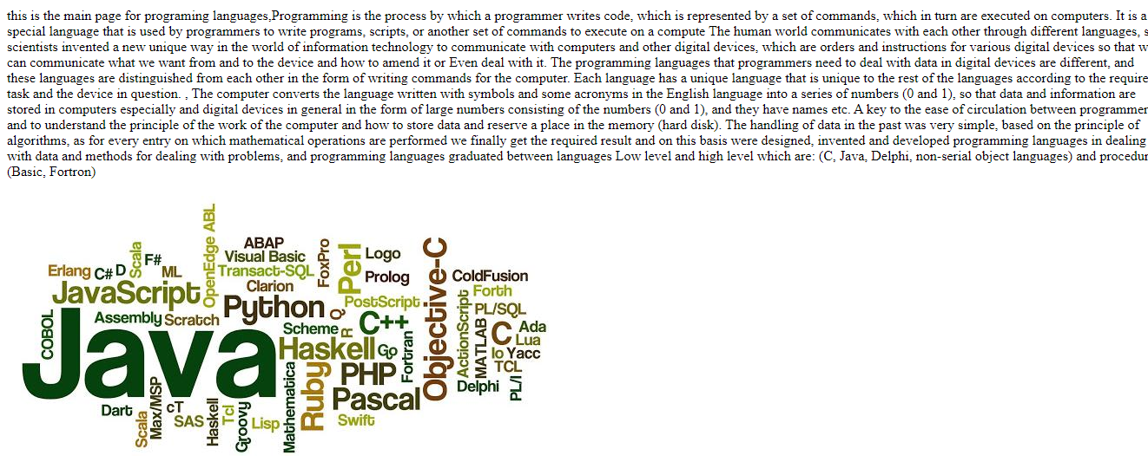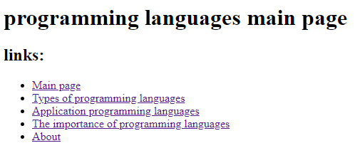

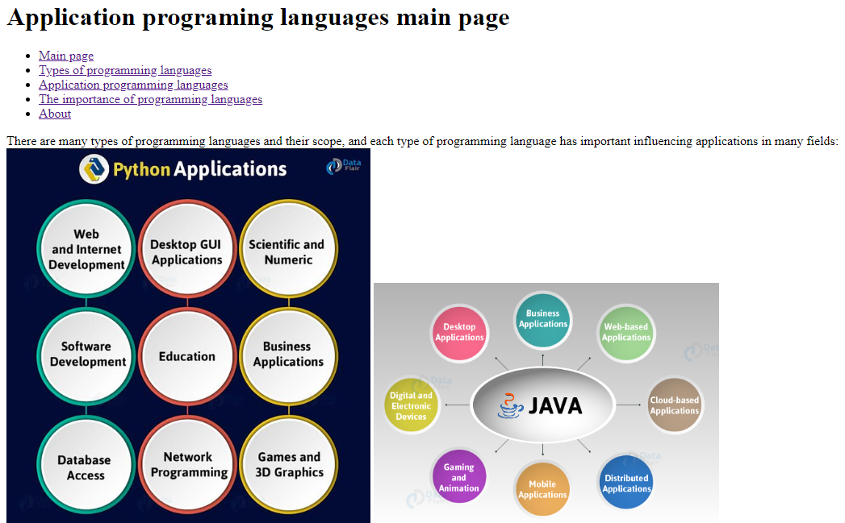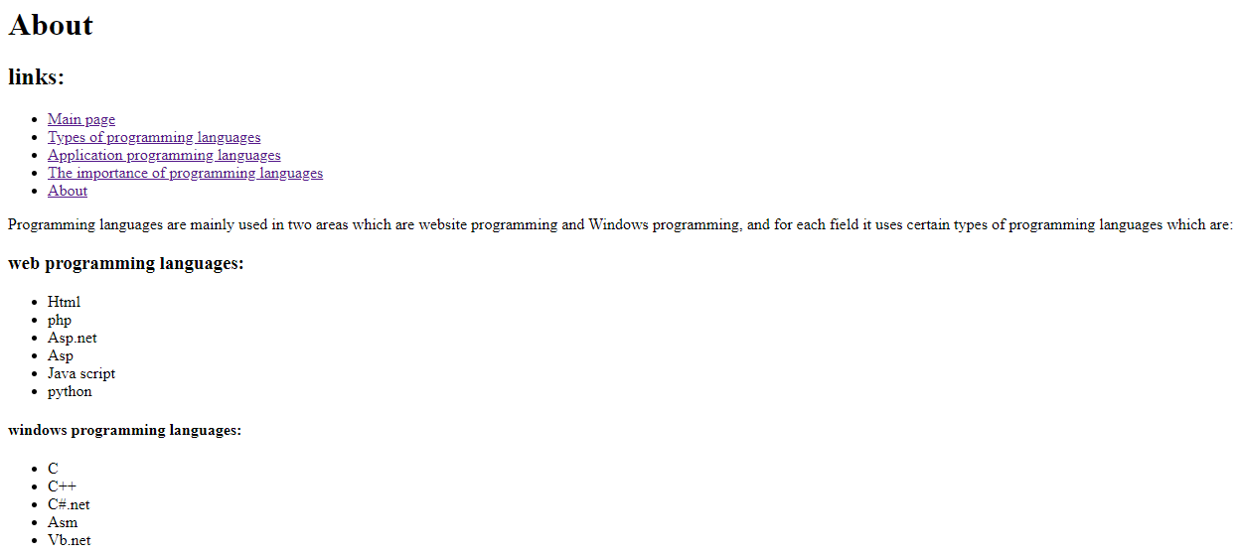

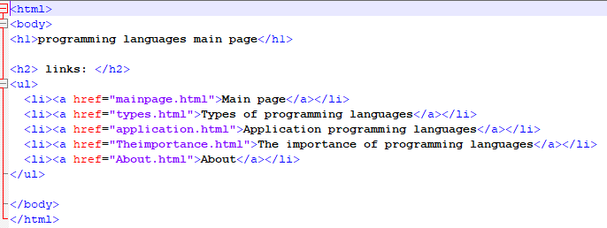**Source code:**

